# Computing system:
- Processor
- Memory
- I/O preference
# This three-computing system communicates with each other using buses.
# Buses:
- Data
- Add
- Control
# Language of microprocessor:
- A Microprocessor is an important part of a computer architecture without which you will mot be able to perform anything on your computer. It is a programmable device that takes in input, performs some arithmetic and logical operations over it and produces the desired output. In simple words, a Microprocessor is a digital device on a chip that can fetch instructions from memory, decode and execute them and give results.
- Microprocessor programming languages can typically be divided into three main types:
- Machine language
- Assembly language
- High-level language
# Machine language:
- Is a low-level language that is understood by computers. Machine language is made up of binary bits 0 & 1. Machine language is also known as machine codes or object code. As machine language consists of only 0 & 1, that’s why it is difficult to understand in raw form. Machine language cannot understood by humans. The CPU processes these features of machine code as input.
- As humans, we write code in high level language. The programming language which we use to write codes such as C, C++ and java are high level languages. High level languages is not understood by computer directly so it is converted into low level machine language to understand the meaning of code and perform execution, computers compile the code written by us and translate into machine code and then execute it. Computers are only able to understand machine language.
# Assembly language:
- A low-level language that helps to communicate directly with computer hardware. It uses mnemonics to represent the operations that a processor has to do. Which is an intermediate language between high-level languages like C++ and the binary language. It uses hexadecimal and binary values, and it is readable by humans.
- It contain mnemonic codes that specify what the processor should do. The mnemonic code that was written by the programmer was converted into machine language (binary language) for execution, an assembler is used to convert assembly code into machine language. That machine code is stored in an executable file for the sake of execution.
- It enables the programmer to communicate directly with the hardware such as registers, memory locations, input/output devices or any other hardware components. Which could help the programmer to directly control hardware components and to manage the resources in an efficient manner.
# History of programming language:
- In the computer world, we have about +500 programming languages with their own syntax and features.
- The father of the computer is Charles Babbage, but the father of the computer didn’t write the first code. It was Ada Lovelace who wrote the first-ever computer programming language, and the year was 1883.
# C programming - ANSI C:
- The first standard for C was published by ANSI.
- In 1983, the American National Standards Institute formed a committee, X3J11, to establish a standard specification of C. In 1985, the first Standard Draft was released, sometimes referred to as C85. In 1986, another Draft Standard was released, sometimes referred to as C86. The prerelease Standard C was published in 1988, and sometimes referred to as C88.
# Why do we use C language in Embedded Systems?
- Embedded C is used to program a wide range of microcontrollers and microprocessors.
- It requires a smaller number of resources to execute in comparison with high-level languages such as assembly programming language.
- It has some additional data types and Keywords, like sbit, sfr which are used for addressing special function registers in memory.
- It allows us to work with hardware devices like sensors, and input-output devices. There are various Embedded C compilers to compile the embedded C program such as Keil Compiler, SPJ compiler…., etc. Embedded Systems can be classified into small-scale, medium-scale, and sophisticated embedded systems. The devices like air conditioners, printers, and mobile phones that we use in our daily lives are programmed by embedded C.
# Types of tool chains:
- In the past there was a trend to integrate the different steps of the software toolchain in one integrated development environment. This trend continues, more and more features are added to IDEs. A trend for the future is more integration of software development with Computer Aided Engineering (CAE) analyses. For example: developers of software must adjust their software-code because there are problems with the dynamic response of the system to control. In the future, CAE models of dynamic response and FE analysis will be inherently embedded into the design of the software.
# How does the compilation/Linking process work?
- The c compilation process converts the source code taken as input into the object code or machine code. The compilation process can be divided into four steps, i.e., Pre-processing, Compiling, Assembling, and Linking.
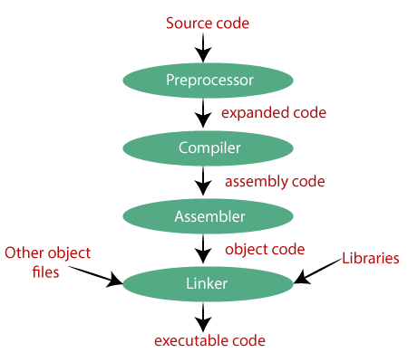
- The preprocessor takes the source code as an input,
and it removes all the comments from the source code.
The preprocessor takes the preprocessor directive and interprets it.
For example, if <stdio.h>, the directive is available in the program,
then the preprocessor interprets the directive and replace this directive
with the content of the 'stdio.h' file.

